Special Educational Needs and Disabilities (SEND) Information Report


Colliers Green Primary School
SENCO:
Sarah Armstrong
Phone: 01580 211335
Email: SENCo@colliers-greenk.kent.sch.uk

SEND Governor:
Elizabeth Hancock

Approved by: | Josie Hopkins | Date: September 2025
Last reviewed on: | September 2025
Next review due by: | September 2026
Contents

1. What types of SEND does the school provide for? 4
2. Which staff will support my child? 5
3. What should I do if I think my child has SEND? 7
4. What happens if the school identifies a need? 8
5. How will the school measure my child’s progress? 9
6. How will I be involved in decisions made about my child’s education? 10
7. How will my child be involved in decisions made about their education? 11
8. How will the school adapt its teaching for my child? 12
9. How will the school evaluate whether the support in place is helping my child? 13
10. How will the school ensure my child has appropriate resources? 13
11. How will the school make sure my child is included in activities alongside pupils who don’t have SEND? 14
12. How does the school make sure the admissions process is fair for pupils with SEN or a disability? 15
13. How does the school support pupils with disabilities? 15
14. How will the school support my child’s mental health and emotional and social development? 16
15. What support is in place for looked-after and previously looked-after children with SEN? 16
16. What support will be available for my child as they transition between classes or settings or in preparing for adulthood? 17
17. What support is available for me and my family? (Local Offer) 18
18. What should I do if I have a complaint about my child’s SEND support? 19
19. Supporting Documents…………………………………………………………………………………………………………….19
20. Glossary 20

Colliers Green Vision & Values

Our Christian Vision
Colliers Green is a family. We are a small rural school set in beautiful surroundings, where everyone feels welcomed and valued. We provide a caring, supportive and calm learning environment, rooted in our Christian values of aspiration, resilience and community. We encourage and nurture our children to flourish, and grow into their potential and achieve academic success, becoming compassionate individuals and valued citizens of God's world.
Jeremiah 17:8
They will be like a tree planted by the water
that sends out its roots by the stream.
It does not fear when heat comes;
its leaves are always green.
It has no worries in a year of drought
and never fails to bear fruit.

Our Values
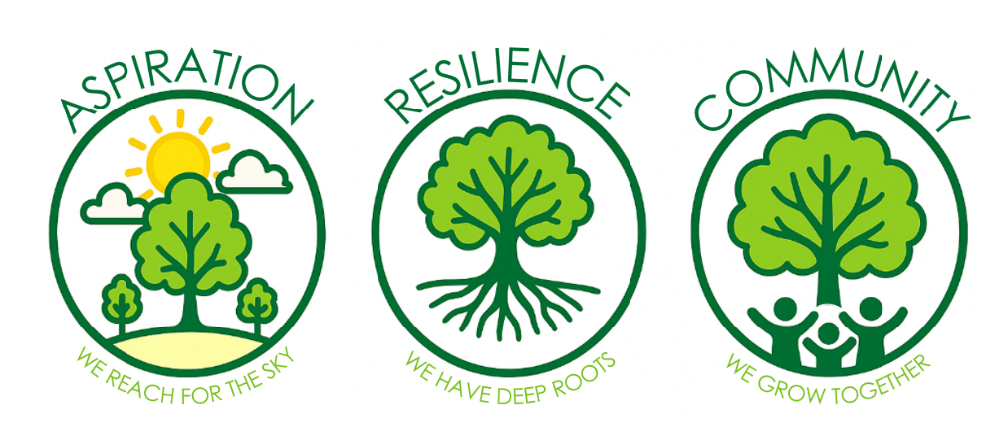
Our vision and values are at the core of everything we do. They underpin our teaching and learning to help create an environment which prepares our pupils for the wider-world as confident, happy and caring citizens.

Dear parents and carers,
The aim of this Information Report is to explain how we implement our SEND policy. In other words, we want to show you how SEND support works in our school.
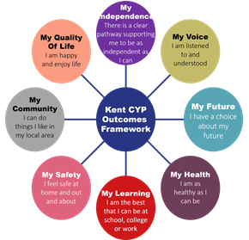
As educational professionals, we are all working towards the ultimate goal of growing independent young people as they prepare for adulthood. All provision and support we provide is working towards achieving the Kent Children and Young People (CYP) Outcomes Framework:

If you want to know more about our arrangements for SEND, read our SEND policy alongside this Information Report.
You can find our SEND policy on our website: https://www.colliers-green.kent.sch.uk/page/?title=Policies&pid=32
Note: If there are any terms we’ve used in this information report that you’re unsure of, you can look them up in the Glossary at the end of the report.

1. What types of SEND does the school provide for?

Our school provides for pupils with the following needs (as outlined in the SEND Code of Practice 2015):

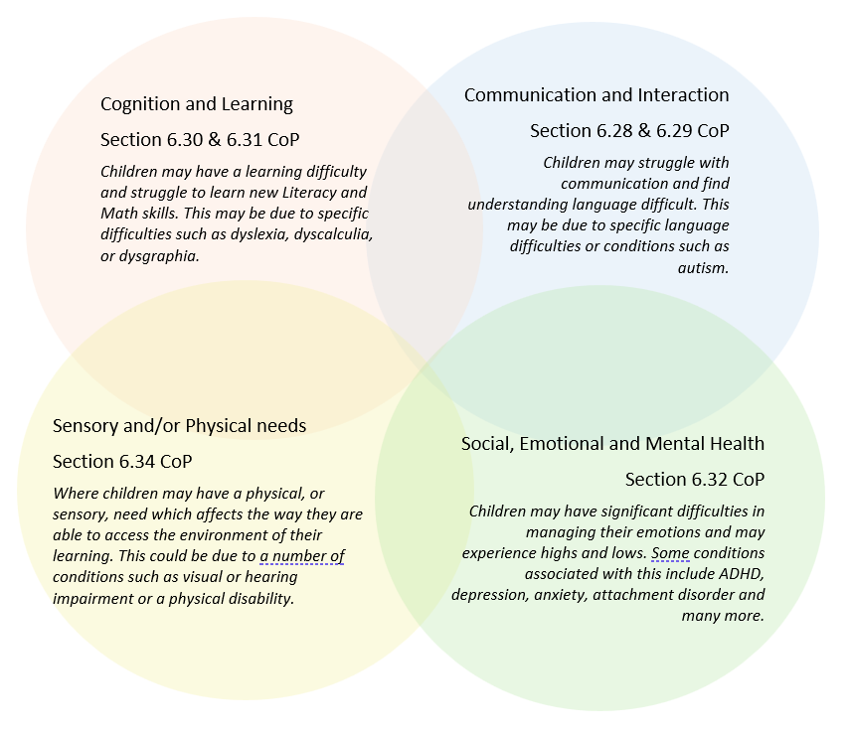

Often you will find that children’s needs overlap and are rarely confined to one area of need, which is why it is important to gain a wholistic overview of your child.
More information about the Areas of Need can be found in the Special educational needs and disability code of practice: 0 to 25 years (link below).
SEND_Code_of_Practice_January_2015.pdf (publishing.service.gov.uk)

2. Which staff will support my child, and what are their key responsibilities?


At Colliers Green all staff are considered responsible for supporting the needs of pupils with SEND. Our staff are committed to regular, high-quality training to ensure that they have the knowledge and skills to better meet a wide range of pupil needs.
Our Special Educational Needs Co-ordinator, or SENCO
The SENCo at Colliers Green is Miss Sarah Armstrong. Miss Armstrong has taught at the school for two years and has been in the SENCo role for one year. Prior to this, she taught for three years at an infant school in Surrey, where she led on Maths and PE. She continues to lead on Maths at Colliers Green, as well as Computing. She is a qualified teacher with a strong passion for supporting children with SEND. Miss Armstrong is currently completing her NPQ in Special Educational Needs, which will be awarded in April 2026.
Class Teachers
All of our teachers receive in-house SEND training, and are supported by the SENCo to meet the needs of pupils who have SEND. Each class is supported by the class teacher, TA and SEND TA.
In the last academic year, staff have received training in Autism with PDA, De-escalation, Emotion coaching, dyscalculia training, communication needs, supporting transitions.
This training includes:
- Safeguarding, and other training to safeguard children such as Prevent and FGM
- Anxiety/ Managing emotional wellbeing
- Nurture UK (using the Boxall profile)
- Behaviour and Self-regulation techniques
- Autism Education Trust
- Emotion Coaching
- Growth mindset
- Quality First Teaching
- Dyslexia Friendly Classrooms
- Developing communication and interaction skills
- Well-being and Involvement,
- Supporting Bereaved Children
- First Aid
All our teachers are responsible for the children within their class and on the occasions that they are unavailable, the class is taken by another qualified teacher or HLTA who knows the children.
Teaching Assistants (TAs), Higher Level Teaching Assistants (HLTAs) and SEND TAs
We have a team of TAs in our school who are trained to deliver SEN provision. We have a mix of class TAs, HLTAs and SEND TAs. Our TAs are trained to deliver interventions such as Sensory Circuits, Lego Therapy, Drawing and Talking, Social Skills, Phonic/math and writing interventions etc.
In the last academic year, TAs have been trained in Autism with PDA, Autism within girls, Emotion coaching, ADHD.
External agencies



Sometimes we need extra help to offer our pupils the support that they need. Whenever necessary we will work with external support services to meet the needs of our pupils with SEND and to support their families.

These may include:

- Child and adolescent mental health services (CAMHS)
- Education welfare officers
- Educational psychologists (Link EP - Helen Webb)
- GPs or paediatricians
- NELFT practitioners
- Occupational therapists
- Therapeutic practitioners
- Behaviour coaches
- Safeguarding services
- School Liaison Officer
- School nurses
- SEND Inclusion Advisor (Link SENDIA - Zerina Slade)
- Specialist Teacher Service (STLS)
- Speech and language therapist

3. What should I do if I think my child has SEND?

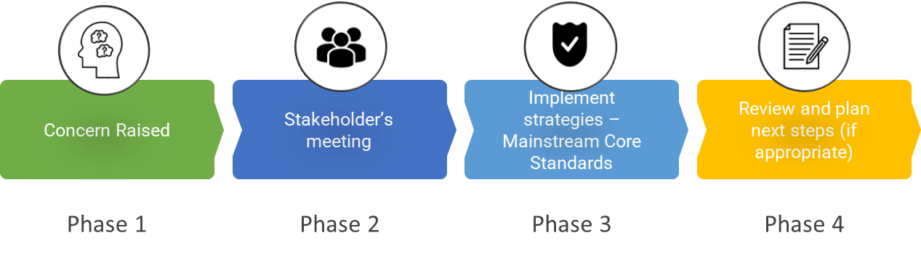

Phase 1 | If you think your child might have SEND, raise your concern with the school so that the SENCO is aware.
Phase 2 | We will meet with you to discuss your concerns and try to get a better understanding of what your child’s strengths and difficulties are. Together we will decide what outcomes to seek for your child and agree on next steps. We will make a note of what’s been discussed and add this to your child’s record.
Phase 3 | We will implement the agreed strategies and monitor these over an agreed period of time. These are likely to be universal strategies set out in the mainstream core standards. A copy of this can be found here: https://www.kelsi.org.uk/__data/assets/pdf_file/0005/117257/Special-educational-needs-mainstream-core-standards-guide-for-parents.pdf . This will initiate the ‘Graduated Approach’ where support will be continually reviewed. See next page for more details.
Phase 4 | If we decide that your child needs SEND support, we will formally notify you and your child will be added to the school’s SEND register. They will receive additional support and this will be reviewed using the assess, plan, do, review model.

4. What happens if the school identifies a need?
The same process is followed if a concern is raised by the school.

All our class teachers are responsible for the monitoring of all pupils who have been identified as having SEND. They also review those who are not making the expected level of progress in their schoolwork or socially. This might include reading, writing or number work or in their relationships with peers.

If the teacher notices that a pupil is having difficulties, they try to find out if the pupil has any gaps in their learning. If they can find a gap, the school will provide appropriate support. Pupils who don’t have SEND usually make progress quickly once the gap in their learning has been filled.

If the pupil is still finding it difficult to make the expected progress, the teacher will talk to the SENCO, and will contact you to discuss the possibility that your child has SEND, and the school will follow the graduated approach (see previous page).

In some cases, and in consultation with parents, it may be necessary to use more specialist assessment tools to help us identify where the specific area of need lies. Colliers Green has access to the following tools:
- Lucid Rapid
- Lucid CoPS
- Dyslexia Portfolio
- Ravens

Any information gathered from these assessments will help to inform the provision put in place for your child.

5. How will the school measure my child’s progress?
At Colliers Green, we have ongoing assessment and monitoring of all the children throughout the school year, including whole class. Small group and individual provision. At Colliers Green we monitor the progress of all pupils formally three times a year at pupil progress meetings. These meetings assess their academic progress as well as emotional well-being. We also use a range of assessments with all the pupils at various points e.g. Early Learning Goals, Speech and Language Link, EYFS Baseline, Boxall Profile, Phonics Screening in Year 1, Read Write Inc Phonic Assessments, SATs, Multiplication Check etc.

We will follow the ‘graduated approach’ to meeting your child’s SEND needs. The graduated approach is a 4-part cycle of assess, plan, do, review.

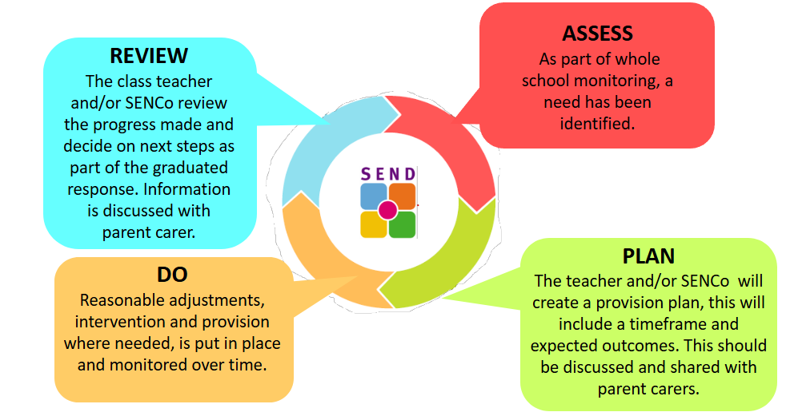
Assess | If your child is not making the expected level of progress, we will make an assessment to find out what strengths and difficulties your child has. We will ask for you and your child’s input, as well as getting help from external professionals where necessary.
Plan | In discussion with you and your child, we will decide what outcomes we are hoping to achieve. We will plan the support that we will offer your child to help them meet those outcomes. We will make a record of this and share it with you and all relevant school staff.
Do | We will put our plan into practice.  The class teacher, with the support of the SENCo, will be responsible for working with your child on a daily basis, and making sure the support we put in place is having the impact we intended.
Review | We will assess how well the support we put in place helped the pupil to meet the outcomes we set. We will use our improved understanding of your child’s needs to improve the support we offer; this may mean the Plan, Assess, Do, Review cycle continues.

6. How will I be involved in decisions made about my child’s education?
We recognise that you know your child’s needs and aspirations best. That’s why we want to ensure you have a clear understanding of the support we’re putting in place, so you can share your insights on what approaches might work most effectively for your child.

At Colliers Green, all parents are given the opportunity to meet with their child’s class teacher at least twice a year to discuss progress. In addition, you will also receive a detailed end of year report. For children with SEND who have a provision plan, there will be a minimum of three meetings each year with the SENCo to review and discuss progress. For SEND children without a provision plan, at least one meeting per year will be arranged with the SENCo to ensure their needs and development are fully considered.
At these meetings we will:
- Set clear outcomes for your child’s progress
- Review progress towards those outcomes
- Discuss the support we will put in place to help your child make that progress
- Identify what we will do, what we will ask you to do, and what we will ask your child to do

In addition to this, parents of pupils with an Education, Health and Care Plan will be invited to contribute to and attend an annual review, which, wherever possible will also include other agencies involved with the pupil. Information will be made accessible for parents.

The SENCo may also attend these meetings to provide extra support.

We know that you’re the expert when it comes to your child’s needs and aspirations. So, we want to make sure you have a full understanding of how we’re trying to meet your child’s needs, so that you can provide insight into what you think would work best for your child.

We also want to hear from you as much as possible so that we can build a better picture of how the SEND support we are providing is impacting your child outside of school.

If your child’s needs or aspirations change at any time, please let us know right away so we can keep our provision as relevant as possible.

If you have concerns that arise between these meetings, please contact your child’s class teacher or Miss Armstrong (SENCo).

7. How will my child be involved in decisions made about their education?
The level of involvement will depend on your child’s age and individual needs. We recognise that no two pupils are the same, so we will decide on a case-by-case basis, with your input.

We may seek your child’s views by asking them to:
- Attend meetings to discuss their progress and outcomes
- Prepare a drawing or complete a ‘child’s view’ form etc
- Discuss their views with a member of staff who can act as a representative during the meeting
- Complete a survey



8. How will the school adapt its teaching for my child?
Your child’s teacher is responsible and accountable for the progress and development of all the pupils in their class.

High-quality teaching is our first step in responding to your child’s needs. We will make sure that your child has access to a broad and balanced curriculum in every year they are at our school.

We will adapt our approaches to how we teach to suit the way the pupil works best. There is no 'one size fits all’ approach to adapting the curriculum, we work on a case-by case basis to make sure the adaptations we make are meaningful to your child and are guided by the Mainstream Core Standards in the first instance. A parents guide can be found here: Mainstream Core Standards - Parents Guide

These adaptations may include:
Adapting our approaches, for example, giving longer processing times, pre-teaching of key vocabulary, reading instructions aloud, etc.

- Adapting our resources and staffing

- Using recommended aids, such as laptops, coloured overlays, visual timetables, larger font, etc.

- Teaching assistants or support staff will support pupils appropriately depending on their presentation of need

- Scaffolding lesson materials

We may also provide the following interventions:

- Language/Speech Link
- Fizzy Fingers
- Sensory Circuits
- Dough Disco
- Write form the Start
- Phonics/writing/maths interventions
- 1:1 Reading
- Lego Therapy
- Draw and Talk
- Social Interventions
- Friendship Groups

Please also see our Whole School Provision Map: Colliers Green Whole School Provision Map - 2025-2026

These interventions are part of our contribution to Kent County Council’s local offer.

9. How will the school evaluate whether the support in place is helping my child?
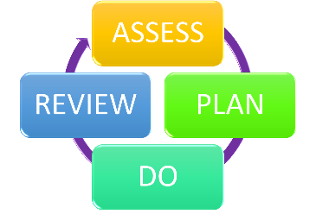
We will evaluate the effectiveness of provision for your child by:
- Seeking the views of the child, parent and class teacher
- Reviewing their progress towards their goals each term
- Reviewing the impact of interventions after a specific number of weeks
- Using pupil questionnaires
- Monitoring by the SENCo
- Using provision maps to measure progress
- Holding an annual review (if they have an education, health and care (EHC) plan) and reviewing SEND Provision Plans

10. How will the school ensure my child has appropriate resources?
It may be that your child’s needs mean we need to provide additional resources such as:
- Writing slopes. Pencil grips, reading rulers, wobble cushions, visual timetables, sensory equipment, ear defenders, weighted blankets, coloured overlays, larger font, laptops etc.

Children may also need:
- Additional resources to support their learning
- Adaptations to in class support
- Further training for our staff
- External specialist expertise - where appropriate, we will consult with external agencies to get recommendations on what will best help your child access their learning and use our best endeavours to ensure these are supplied. This maybe seeking advice from the Specialist Teaching and Learning Service (STLS) or having a consultation with our Link Speech and Language therapist.

We will be able to use the school’s Notional SEN funding to put towards any adaptation needed – this notional funding comes from a school’s budget and helps to cover the costs of supporting pupils with SEND. In some cases, the school may need to apply for ‘top-up funding’ through the ‘Community of Schools’ route – further information will be shared regarding this route once it becomes available. Some equipment may also be available via loan.

11. How will the school make sure my child is included in activities alongside pupils who don’t have SEND?

At colliers Green, we work with parents and outside agencies to ensure there are no barriers to pupils, with or without SEND, enjoying the same activities, including physical activities. It may be necessary for some pupils to receive interventions in addition to a broad and balanced curriculum to enable this to happen.

All of our extra-curricular activities and school visits are available to all our pupils, including our before and after-school clubs.

All pupils are encouraged to go on our school trips, including class trips, visit to the Church, the Christmas pantomime and our residential trip in Class 4.

All pupils are encouraged to take part in forest school, sports day, school plays, trips and special workshops. We also encourage all pupils to take part in enrichment activities that take place outside of school hours such as discos and school fairs.

No pupil is ever excluded from taking part in these activities because of their SEN or disability and we will make whatever reasonable adjustments are needed to make sure that they can be included.

12. How does the school make sure the admissions process is fair for pupils with SEN or a disability?
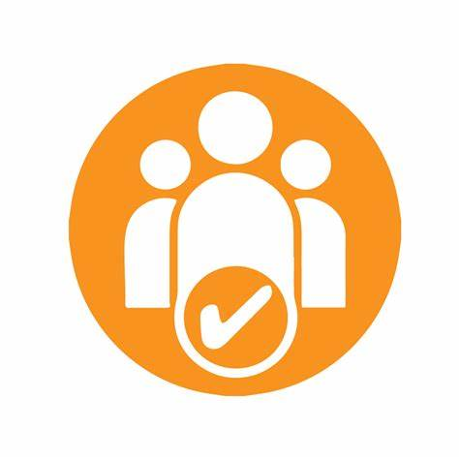
Colliers Green Primary School is a mixed form entry school with a published admission of 112 places, in which we admit 16 children into each year group.

Pupils with an Education, Health and Care Plan do not apply to schools for a place through the main round admissions process. For children who have an education, health and care (EHC) plan and are looking for a reception place, or to transfer from a different setting, this is organised by the Local Authority directly, not the school. You will be asked by your named EHCP Coordinator to state your preference of school. Kent County Council will then send us a copy of your child’s EHCP as part of the consultation process. You will then be informed of the outcome and, if a place is offered, you will be contacted via the SENCo to discuss transition arrangements. If your child is currently being assessed for an EHC plan but it has not been finalised, you are advised to apply for a school place using the standard admissions process (if applying for a reception place) or through the school’s ‘in-year admissions process’ if your child is looking to transfer from another setting. This will ensure they have a school place if the EHC plan is not agreed.

When parents wish to look at the school, a tour can be organised with by Miss Armstrong (SENCo) or Mrs Addis (Office Manager) if there are any specific questions related to how your child’s needs will be met at Colliers Green Primary School.

Please see our school’s Admissions policy for further details: Colliers Green Admissions Policy

13. How does the school support pupils with disabilities?

You’re disabled under the Equality Act 2010 if you have a physical or mental impairment that has a ‘substantial’ and ‘long-term’ negative effect on your ability to do normal daily activities.

Reasonable adjustments are changes made to ensure that disabled pupils can fully participate in their education and access all the facilities offered at Colliers Green. The school recognises its duty to make such adjustments to prevent disabled pupils from being placed at a substantial disadvantage compared to their non-disabled peers. This responsibility applies across all areas of school life, including policies on exclusion and behaviour, the physical environment (such as entrances, exits, toilets, lighting, flooring, and furniture), and the provision of auxiliary aids and services (for example, specialist staff or supportive equipment).

These adjustments are tailored to the individual needs of each child. For instance, a pupil with autism might be allowed to wear ear defenders or adapt their uniform to accommodate sensory sensitivities. Others may benefit from having a quiet space at break times or a dedicated workstation in the classroom. Some pupils may also need additional support to take part in school trips, such as extra staff to accompany them, specific risk assessments, or advance visits to assess accessibility.
As part of its ongoing commitment, the Governing Body regularly reviews the suitability of the curriculum and learning environment and makes improvements where necessary, in line with the school’s accessibility plan.

See Accessibility Plan for more information: Equality Policy

14. How will the school support my child’s mental health and emotional and social development?
Our vision at Colliers Green is to provide a welcoming, safe and nurturing learning environment and to make all our children, parents, staff and visitors feel valued, important and cared for. This we feel is fundamental to our wellbeing provision. We strongly believe that all children need to feel safe and happy in order to thrive and develop into the best person they can be.
At Colliers Green we have Wellbeing Champions in classes 2, 3 & 4. These are pupils who have shown an interest in championing positive Mental Health and Wellbeing. The champions will help Mrs. Salter (FLO) to capture the “Childs voice” on ideas of how the school can ensure the children are safe, happy and confident and so they know who they can turn to if they need help and support.
We provide support for pupils to progress in their emotional and social development in the following ways:
- Access to our SENCo and FLO
- Draw and Talk sessions with our FLO
- A safe space for pupil to use when dysregulated, upset or agitated
- Robust monitoring via Boxall Profile
- Access to counselling via Spurgeons
- Daily check-ins with a trusted adult
- Social skills group
- We listen to the views of pupils with SEN through our pupil voice questionnaires
- Pupils with SEND are also encouraged to take park in extra-curricular clubs to promote teamwork/building friendships
- If required an external referral to School Health, Emotional Well-Being Team (NEFLT) or Kent and Medway Children and Young People’s Mental Health Service (CYPMHS)
We have a ‘zero tolerance’ approach to bullying. Please see our Behaviour Policy and Anti-bullying policy on our school website: https://www.colliers-green.kent.sch.uk/page/?title=Policies&pid=32

15. What support is in place for looked-after and previously looked-after children with SEND?
Josephine Hopkins, our Headteacher, is our designated teacher for looked-after children and previously looked-after children here.
Josephine Hopkins will work with Sarah Armstrong, our SENCo, to make sure that all teachers understand how a looked-after or previously looked-after pupil’s circumstances and their SEND might interact, and what the implications are for teaching and learning.
Pupils who are looked-after or previously looked-after will be supported much in the same way as any other child who has SEND. However, looked-after pupils will also have a personal education plan (PEP). We will make sure that the PEP and any SEND support plans or EHC plans are consistent and complement one another.

16. What support will be available for my child as they transition between classes or settings or in preparing for adulthood?

Children go through a number of transitions during their school journey, with each stage bringing its own differences and impact on the child. While most children adapt to these changes naturally over time, some may require additional support. To help with this, personalised transition programmes are put in place for children with SEND, aiming to make the process as smooth and successful as possible.
Transition Support
- Pre-school to Foundation Stage
  - Open days, new parents evening, pre-visit to nursery setting, meeting with parent/carers and child, social stories, photographs of new teachers/class, FLO can support child and parents
  - As a school, we have some settling in sessions in July before joining in September to allow children to know our setting and feel more comfortable. We also complete home visits during this time to allow the children to start making a relationship with their teachers.
- Moving up a year group
  - Moving up mornings, social stories, photographs of new teachers/class, opportunities to meet all staff in their new class, children know all staff in school already through worship, events, attendance at clubs, transition meetings between teachers, meet the teacher sessions for parents.
- Year 6 to Secondary School
  - Visit to and from secondary school staff, transition week/days (dependent on Secondary school), transport talks, transition talks and lessons, FLO support for pupils and parents, STLS to continue to support on their caseload, additional transition meetings for SEN children.
- Late admissions/transfer to our school
  - Visits to meet children and new teachers, trial day/morning/afternoon, peer buddy, FLO to support if necessary, discussions with previous school.

17. What support is available for me and my family?
If you have questions about SEND, or are struggling to cope, please get in touch to let us know. We want to support you, your child and your family.

To see what support is available to you locally, have a look at Kent County Council’s local offer. KCC published information about the local offer on their website: Kent County Council - About the SEND local offer

Our local special educational needs and disabilities information advice and support services (SENDIASS) organisations are:
- Link to all Local SENDIASS Organisations -
- IASK - (IASK) - a free, confidential and impartial service based in Kent to support you and your family. IASK also offer parent workshops and local events.
- Kent PACT - (PACT) - is the parent carer forum for parents of children and young people with disabilities. Join their forum to help get your voice heard and meet other

Local charities or support networks that offer information and support to families of pupils with SEND are:
- Days out and activities for SEND children and young people - KCC
- The Kent Autistic Trust
- Space 2 Be Me – Maidstone, Tonbridge and Malling and Tunbridge Wells
- EYFS
  - Kent Family Hub - meet other parents, have fun or get information, advice and support
  - Early Help (Support for families) - find local services that supports Kent families with the educational, social and emotional needs of children.
  - Portage - supporting pre-school children with SEND - work with families and focus on play activities to help your child grow.
  - Start for Life - improves the health of babies and children from conception to age 2.
- For children and young people
  - Kent Resilience Hub - a wide range of resources to support your child growing up into adulthood and understanding their behaviour.
  - MASHs - attend appointments with different services in the same place on the same day, including members from health, social care, education and voluntary services.
  - Short Breaks for Disabled Children Grants - a positive, fun activity for disabled children (0-18) to take part in. They can be anything from an after-school activity or weekend club to an overnight stay.

National charities that offer information and support to families of pupils with SEND are:

- IPSEA
- SEND family support
- NSPCC
- Family Action
- Special Needs Jungle

18. What should I do if I have a complaint about my child’s SEND support?
Colliers Green CE Primary School’s Complaints procedure can be found here: https://www.colliers-green.kent.sch.uk/attachments/download.asp?file=2524&type=pdf
A concern or complaint can be made in person by parents, carers (including parents or carers of children no longer at the school) and members of the public, in writing or by telephone. They may also be made by a third party acting on behalf on a complainant, as long as they have appropriate consent to do so.
Concerns should be raised with the class teacher in the first instance. At this stage informal mediation may be offered. While this can be useful in helping the school and complainants reach an agreement and move forward, there are times when it may not be the most appropriate course of action.
Mediation can:
- provide a helpful mechanism for discussion when a concern is raised
- help to rebuild the relationship between all parties
It should not be used as a substitute for an investigation during the formal stages of the complaints procedure.
If neither the complainant nor the school considers that mediation will serve any practical purpose at this point, the complainant will not be prevented from moving to the next investigative stage of the complaints procedure.
If the issue remains unresolved, the next step is to make a formal complaint.
Complainants should not approach individual governors to raise concerns or complaints. They have no power to act on an individual basis and it may also prevent them from considering complaints at Stage 2 of the procedure.
Complaints against school staff (except the headteacher) should be made in the first instance, to Dr Josephine Hopkins (the headteacher) via the school office. Please mark them as Private and Confidential.
Complaints that involve or are about the headteacher should be addressed to Mr John Speller (the Chair of Governors, care of the complaints co-ordinator), via the school office. Please mark them as Private and Confidential.
Complaints about the Chair of Governors, any individual governor or the whole governing body should be addressed to the Clerk to the Governing Body via the school office. Please mark them as Private and Confidential.
For ease of use, a template complaint form is included at the end of this procedure. If you require help in completing the form, please contact the school office. You can also ask third party organisations like the Citizens Advice to help you. In accordance with equality law, we will consider making reasonable adjustments if required, to enable complainants to access and complete this complaints procedure. For instance, providing information in alternative formats, assisting complainants in raising a formal complaint or holding meetings in accessible locations. Explain your school’s approach here, including an outline of how complaints will be handled, and how parents can complain.
Complaints about SEND provision in our school should be made to class teacher, SENCo or Headteacher in the first instance. They will then be referred to the school’s complaints policy.
If you are not satisfied with the school’s response, you can escalate the complaint. In some circumstances, this right also applies to the pupil themselves.
To see a full explanation of suitable avenues for complaint, see pages 246 and 247 of the SEND Code of Practice.
If you feel that our school discriminated against your child because of their SEND, you have the right to make a discrimination claim to the first-tier SEND tribunal. To find out how to make such a claim, you should visit: https://www.gov.uk/complain-about-school/disability-discrimination
You can make a claim about alleged discrimination regarding:
- Admission
- Exclusion
- Provision of education and associated services
- Making reasonable adjustments, including the provision of auxiliary aids and services
Before going to a SEND tribunal, you can go through processes called disagreement resolution or mediation, where you try to resolve your disagreement before it reaches the tribunal. Mediation Support and Appeals Information - Kent County Council

19. Supporting documents

- Equality Policy
- Child Protection and Safeguarding Policy
- Behaviour and Exclusion Policy
- Accessibility Plan
- Attendance Policy
- Special Educational Needs and Disabilities Policy
- SEN & Disabilities Code Of Practice 2015
- Mainstream Core Standards - Guide for Parents

20. Glossary
- Access arrangements – special arrangements to allow pupils with SEND to access assessments or exams
- Annual review – an annual meeting to review the provision in a pupil’s EHC plan
- Area of need – the 4 areas of need describe different types of needs a pupil with SEND can have. The 4 areas are communication and interaction; cognition and learning; physical and/or sensory; and social, emotional and mental health needs.
- CAMHS – child and adolescent mental health services
- Differentiation – when teachers adapt how they teach in response to a pupil’s needs
- EHC needs assessment – the needs assessment is the first step on the way to securing an EHC plan. The local authority will do an assessment to decide whether a child needs an EHC plan.
- EHC plan – an education, health and care plan is a legally-binding document that sets out a child’s needs and the provision that will be put in place to meet their needs.
- First-tier tribunal/SEND tribunal – a court where you can appeal against the local authority’s decisions about EHC needs assessments or plans and against discrimination by a school or local authority due to SEND
- Graduated approach – an approach to providing SEND support in which the school provides support in successive cycles of assessing the pupil’s needs, planning the provision, implementing the plan, and reviewing the impact of the action on the pupil
- Intervention – a short-term, targeted approach to teaching a pupil with a specific outcome in mind
- Local offer – information provided by the local authority which explains what services and support are on offer for pupils with SEND in the local area
- Outcome – target for improvement for pupils with SEND. These targets don't necessarily have to be related to academic attainment
- Reasonable adjustments – changes that the school must make to remove or reduce any disadvantages caused by a child’s disability
- SENCO – the special educational needs co-ordinator
- SEN – special educational needs
- SEND – special educational needs and disabilities
- SEND Code of Practice – the statutory guidance that schools must follow to support pupils with SEND
- SEND information report – a report that schools must publish on their website, that explains how the school supports pupils with SEND
- SEND support – special educational provision which meets the needs of pupils with SEND
- Transition – when a pupil moves between years, phases, schools or institutions or life stages

