
Report to governors on special educational needs and disability

We worked with our associate education expert, Lorraine Petersen, to create this guide to the topics that governors should expect to be covered in a report on special educational needs and disability (SEND).
- SEND profile
Mainstream school governors should see:
Type of support | Number of pupils
Special educational needs (SEN) support | 16
Education, health and care (EHC) plan | 2

Special school governors should see:
Areas of need | Number of pupils
Specific learning difficulty (SpLD) | 11
Moderate learning difficulty (MLD) | 3
Severe learning difficulty (SLD) | 0
Profound and multiple learning difficulty (PMLD) | 1
Social, emotional and mental health (SEMH) | 3
Communication and interaction needs | 2
Sensory and/or physical needs | 1
Some areas of need are children’s’ secondary need.
- EHC plans
Currently two children have EHC plans, one in reception and one in year 6. EHCP annual reviews are carried out once a year, with interim reviews held if needed.
Referrals to outside agencies and specialist teachers are made to support areas of the ECHP where progress is not being made.
Both children with EHCPs have 1:1 teaching assistants and lessons are differentiated to their needs.

- Identifying pupils with SEN (for mainstream schools)
- Pupil progress meetings
- Lucid and CoPs assessments
- Specialist teacher – Mrs Beales
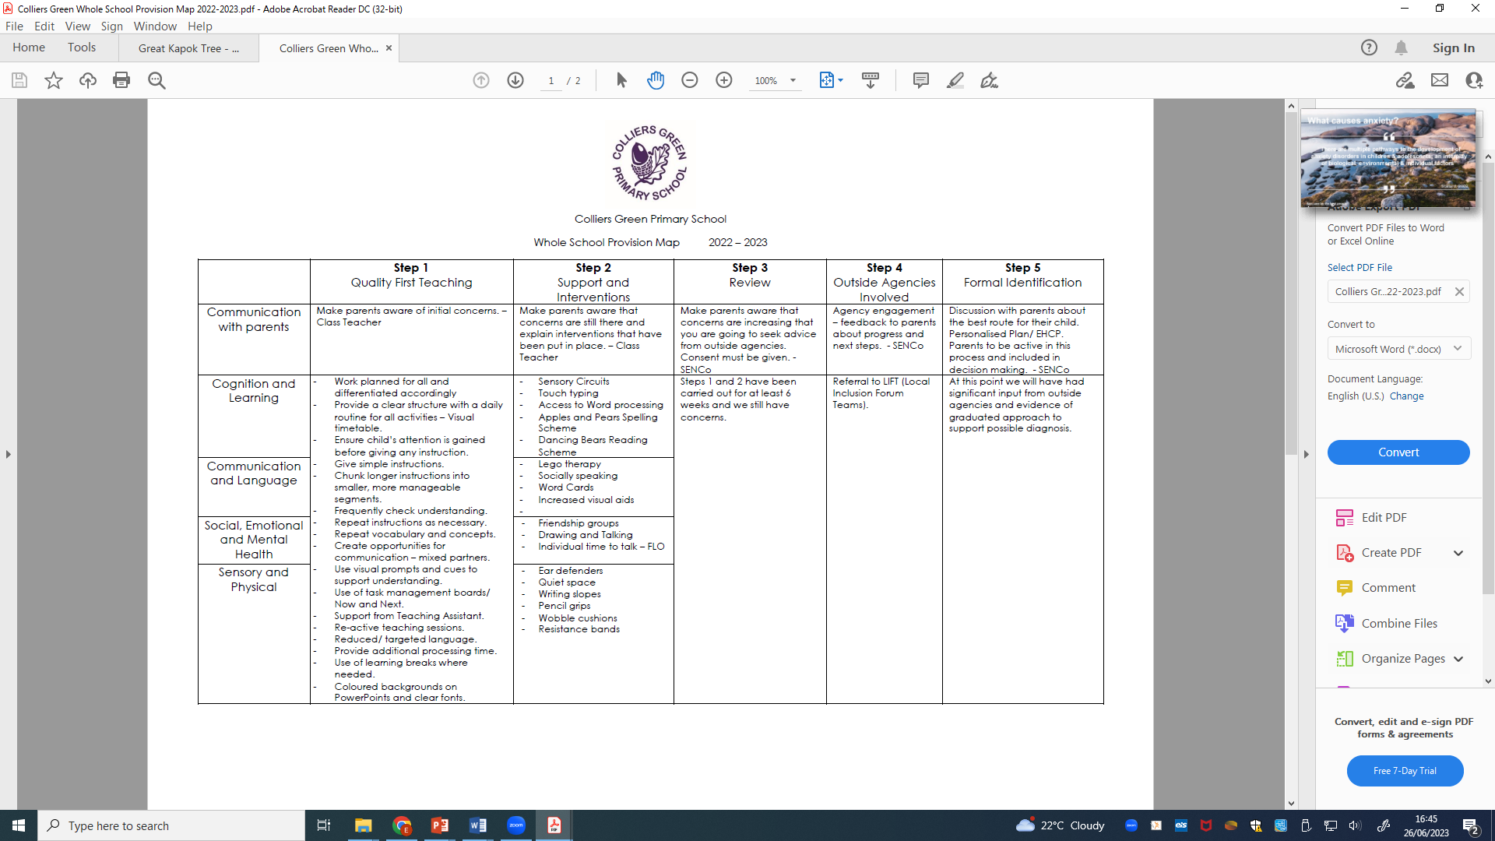
- LIFT referrals
- Progress made by pupils with SEN
In pupil progress meetings, progress is discussed and data added to class provision maps. Interventions are targeted and monitored. Class teachers are aware of Personalised plans, which can be easily accessed. Class Teachers know their children and what targets they are working towards.
- SEND funding
The school currently receives High Needs Funding for four pupils, which pays for 1:1 support for these children. The school budget, received from Kent CC, includes money for supporting children with SEND.
This money is spent on:
- TA hours to support children with SEND
- CPD for all staff
- Resources
- Renewal of licences for assessment materials
- SLA for Kent Educational Psychologist Service
- Training needs are identified through:
- Audit of current and upcoming need of the children
- Audit of staff strengths when new staff starts our school
- Staff development
Training is accesses through a range of difference courses including:
- The Education People CPD
- The National Collage
- Local inclusion forums
Training is selected based on the needs of the children.
- Work with external agencies
Outside and external agencies that have been utilised:
- Dyslexia specialist teacher
- Specialist Teacher for Cognition and Learning & Communication & Interaction
- Local Inclusion Forum
- Visits to Five Acre Wood
- Kent SEN officer

