Bubbles | 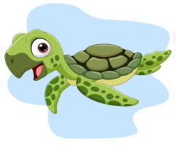  Shelly | Tiny | 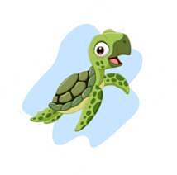  Aqua | Tim | Flipper | 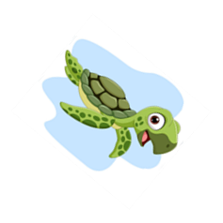  Pearl | Olive | Coral | Jade
Oreo | Precious | Bob | Oceania | Buddy | Destiny | Sparkle | Marina | Luna | Trixie
Salty | Terry | Captain | Star | Hope | Twix | Duke | Twinkle | Holly | Rascal
Diamond | Oliver | Speedy | Tod | Shelby | Opal | Cookie | Sapphire | Daisy | Cooper
Star | Tammy | 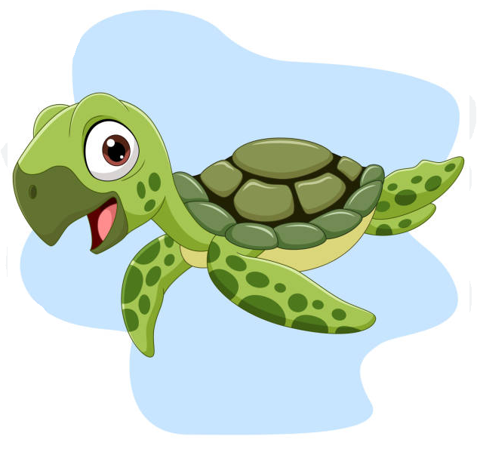  Oscar | Bentley | Lilly | Blue | Marley | Titan | Odessa | 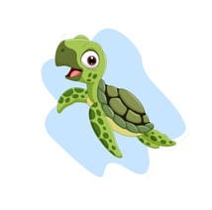  Tiggy
Rocky | Dizzy | Crusty | Astra | Flash | Crystal | Blaze | Ripples | Shadow | Beaky
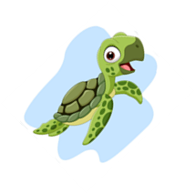  Apollo | Flippy | Tucker | Turbo | Gizmo | Squirtle | Lucky | Dancer | Taco | Rosie
Tessa | Scooter | Ruby | Charlie | Queenie | Aurora | Peanut | Zoom | Herbie | Snapper
Dasher | Timmy | Bertie | Roxy | Shimmer | Zippy | Major | Ozzy | Poppy | Terri
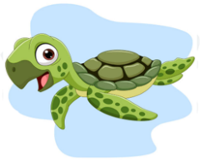  Chirpy | Faith | Tally | Skye | Tommy | Mack | Tully | 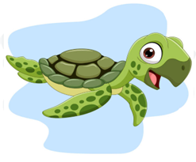  Candy | Emerald | Fern

