EXPRESSIVE ARTS AND DESIGN
40-60 Explores what happens when they mix colours
.Experiments to create different textures.
Understands that different media can be combined to create new effects.
Initiate movement and gesture to respond to feelings,ideas and experiences.

Eye on the goal -They safely use and
explore a variety of materials, tools
and techniques, experimenting with
colour ,design, texture, form and function.

- Building a farmyard barn
- Egg shell collage
- Chick representations
- Moving like chicks
- Building shapes
UNDERSTANDING THE WORLD
40-60 Know familiar places identifying features, e.g. play area, flower beds, pond, café in a park.
Eye on the goal -They talk about the features of their own immediate environment and how environments might vary from one another.
- Looking at change over time
- Exploring similarities and differences
- Finding out how to look after our eggs and chicks

LITERACY
40-60 Can segment the sounds in simple words and blend them together and knows which letters represent some of them. Continue a rhyming string.
Hears and says the initial sound in words.
Can segment the sounds in simple words and blend them together.
Links sounds to letters, naming and sounding the letters of the alphabet.
Eye on the goal -They also read some common irregular words. Children use their phonic knowledge to write words in ways which match their spoken sounds.

- Beginning to recognise familiar words in books
- Beginning to segment the sounds in words and blend some together to write and read.
- Writing opportunities to use initial sounds, some sounds in correct order.
- Name writing ,labels, lists.
- Segmenting sounds in order to write sentences.
- Egg rules
- How to look after the chicks
- Who helps us and how?
- Who can I ask for help?
COMMUNICATION AND LANGUAGE
40-60 Maintains attention, concentrates and sits quietly when required to do so. Answers questions based on a story.
Shows interest when presented with alternative possibilities.
Eye on the goal -They listen to stories, accurately anticipating key events and respond to what they hear with relevant comments, questions or actions.

- Sharing ideas based around our learning questions.
- Participating in discussions.
- Sharing stories together, predicting what might happen next
- Discussing how and why things might happen. Linking ideas.
- Hen stories – Rosie’s walk, little red hen

PSED
40-60 Confident in speaking in front
of a small group. Chooses
equipment necessary to complete
a task. Can describe self in positive
terms and talk about abilities.
Eye on the goal -They are confident
to speak in a familiar group, will
talk about their ideas, and will
choose the resources they need for
their chosen activities.
They say when they do or don’t
need help.

- Sharing news from home
- Sharing ideas with the class
- Circle time
- Sharing games
- Changing for PE
- Selecting resources within the classroom
PHYSICAL DEVELOPMENT
40-60 Negotiates space successfully when playing racing and chasing games with other children, adjusting speed or changing direction to avoid obstacles. Travels with confidence and skill around, under, over and through balancing and climbing equipment.
Eye on the goal -They move confidently in a range of ways, safely negotiating space.

- Mark making  - Outdoor games  - Links to home sports clubs/activities  - PE | 30

TERM 3
Who can I ask for help?
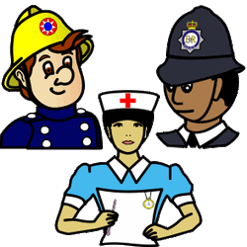

Which came first the chicken or the egg?
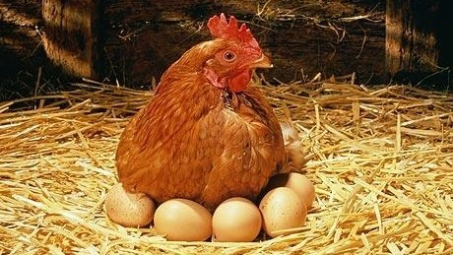Living eggs experience
RE
Which stories are special and why?
(New Testament)

MATHS
40-60 Recognises some numerals of personal significance. Finds the total number of items in two groups by counting all of them and starting to use ‘counting on’.
In practical activities and discussion, beginning to use the vocabulary involved in adding and subtracting including counting on and back.
Eye on the goal -Using quantities and objects, they add and subtract two single-digit numbers.

- Counting and comparing groups of objects
- Labelling groups of objects with correct numbers
- Counting on from a number
- Adding and subtracting using objects and numbers
- One more and one less
- 2D shape language, sorting and symmetry
- Money
- Shape building

